**TMC2226 Manual**

**TMC2226 V1.0 Stepper Motor Driver**

Working Mode: **UART(recommend)** or STEP/DIR

Microsteps: Up to 1/256

Voltage Range: 4.75-29V DC

Size: 15.24*20.32mm

Motor Phase Current: 2.8A Peak

**TMC2226 V1.0 Stepper Motor Driver**

Ultra-quiet, good heat dissipation, locked-motor test, three working modes.

2-phase stepper motors up to 2.8A coil current (peak), 2A RMS.

CoolStep current control for energy savings up to 75%.

Working Mode: UART,STEP/DIR

Voltage Range: 4.75-29V DC

Microsteps: Up to 1/256

2-phase stepper motors up to 2.8A coil current (peak), 2A RMS

**We recommend to use UART mode.**

**Benefits of UART mode:**

**Motor parameters can be set by firmware or screen.**

**Actual interpolated microsteps can be combined to achieve maximum torque.**

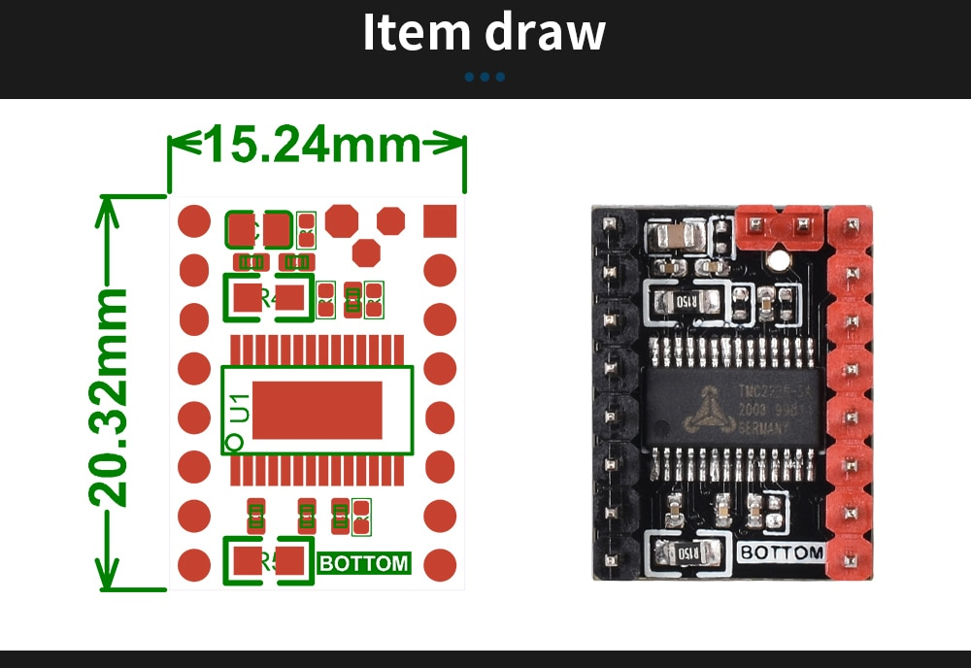

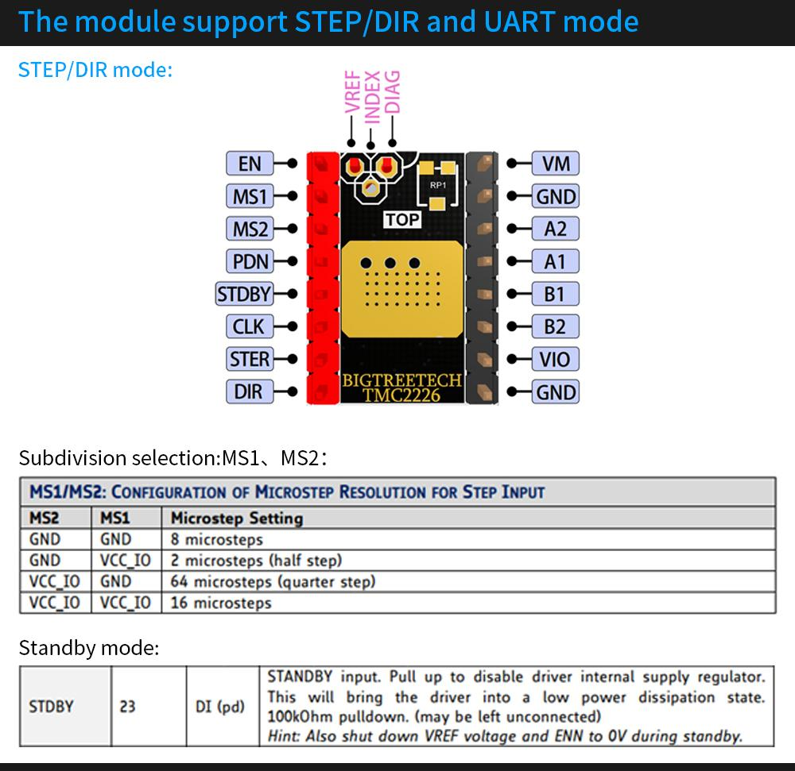

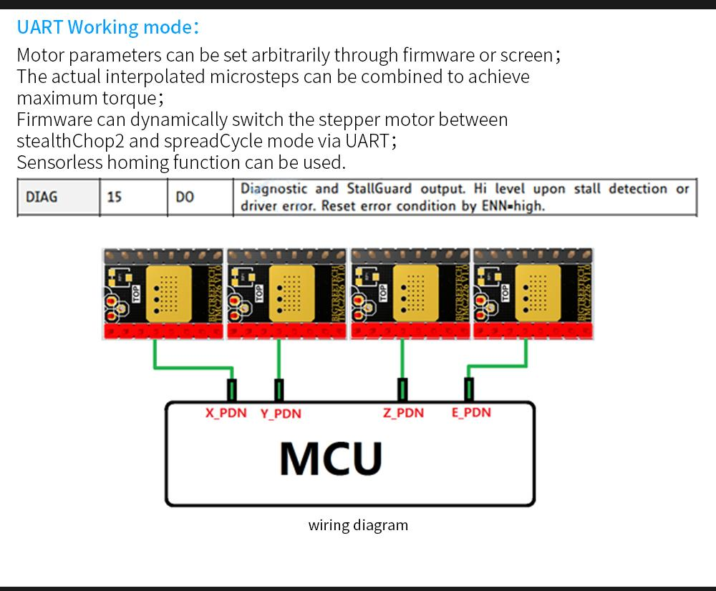

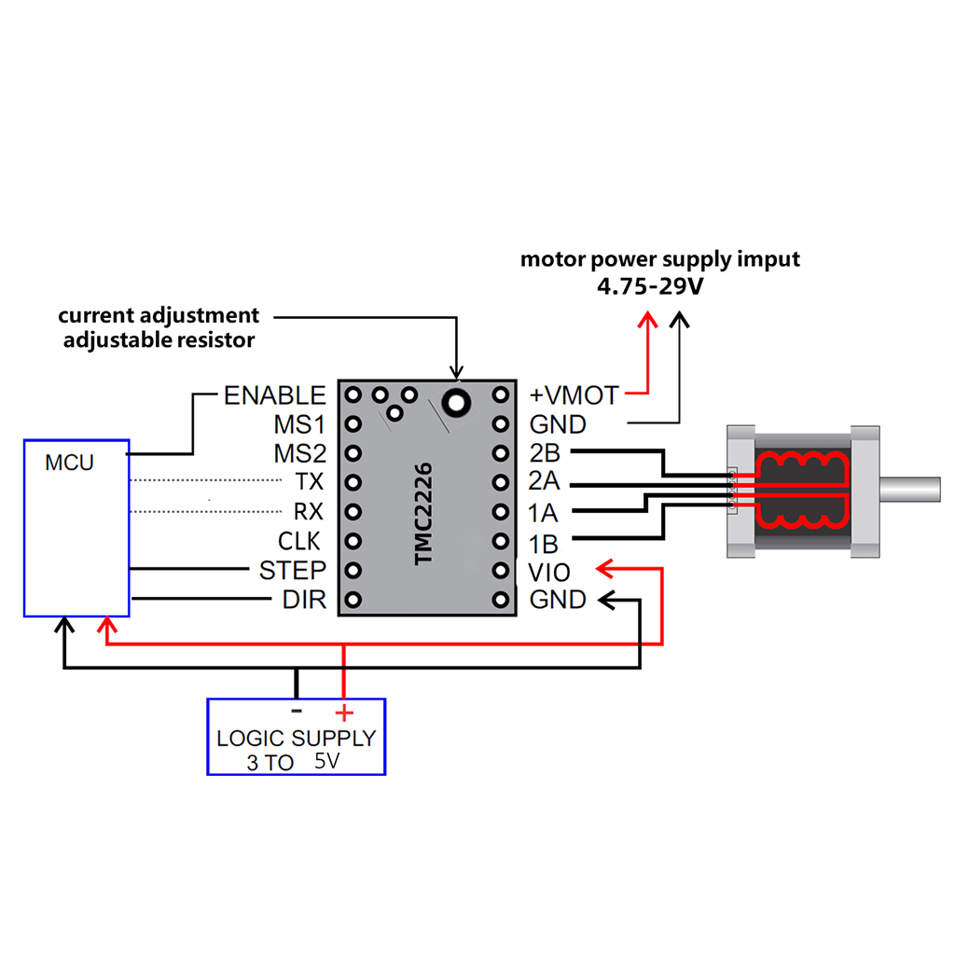

Marlin config

Use following config until official support comes along the way

use TMC2225 as TMC2208 with #define *_RSENSE 0.15.  
I think it will be similar with them (TMC2209).

I use #define X_DRIVER_TYPE TMC2209 and it works for TMC2226.